Week 3 – Assignment
Marco Garcia
The University of Arizona Global Campus
CST499: Capstone for Computer Software Technology
Professor: Charmelia Butler
August 24, 2026

Introduction
The implementation phase of the Online Course Enrollment System involved turning the previous system requirements into a basic working website. The system was developed using XAMPP, PHP, MySQL, phpMyAdmin, HTML, and CSS. XAMPP provided the local environment needed to run the website and database on a computer before the system is placed on a public server. Three main pages were developed during this phase: a landing page, a student login page, and a student registration page. A MySQL database was also created to store account information entered through the registration form. This paper explains the development of the website pages, the MySQL database and connection, and the process used to successfully save new student information in the database.
Running PHP With XAMPP
XAMPP was used as the local development environment for the project. To run a PHP file, the Apache Web Server and MySQL Database were first started through the XAMPP application. Both services must be running because Apache processes and displays the PHP pages while MySQL provides the database used by the website. The project folder, named CourseEnrollment, was placed inside the XAMPP htdocs directory. PHP files stored in this location could then be accessed through localhost in a web browser. For example, the landing page was accessed through the CourseEnrollment folder followed by index.php. This provided a simple way to test changes to the website during development.
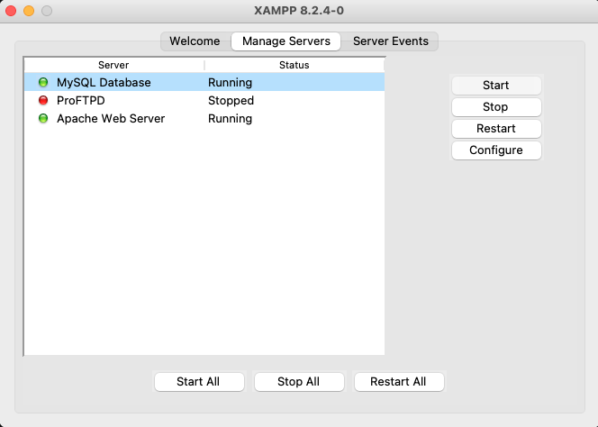Figure 1. XAMPP server environment used for the Online Course Enrollment System.
Landing and Login Page Development
The landing page was created as index.php and serves as the starting point for the website. The page displays the name of the Online Course Enrollment System and provides links for students to either log in or create a new account. The design was intentionally kept simple so users can easily understand where to go when entering the system. Basic CSS was used to improve readability without adding unnecessary complexity.
Figure 2. Online Course Enrollment System landing page.
The login page was developed as login.php. It contains fields for the student's ID and password along with a Login button. Links were also included so a new user can move directly to the registration page or return to the landing page. The current implementation establishes the layout needed for student authentication while keeping the focus of this phase on account registration and database storage.
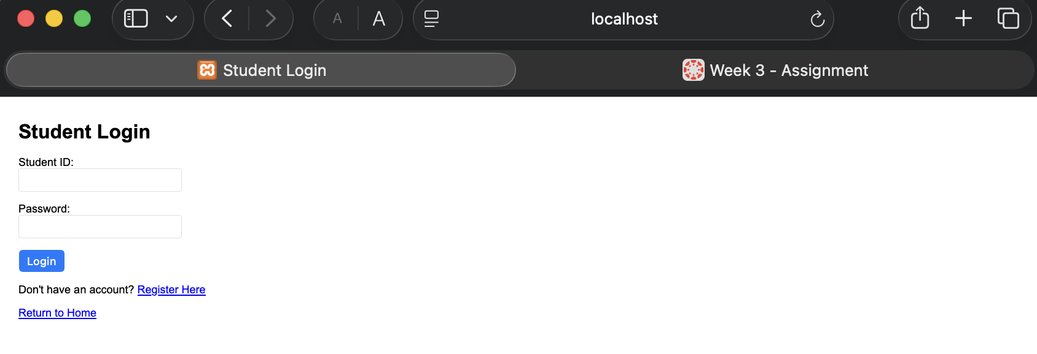Figure 3. Student login page.
Registration Page Development
The registration page was developed to collect the information needed to create a student account. The form includes Student ID, first name, last name, email address, phone number, and password fields. Each field is marked as required so the form cannot be submitted with missing information. This layout provides the basic information needed to identify a student and create an account in the system.
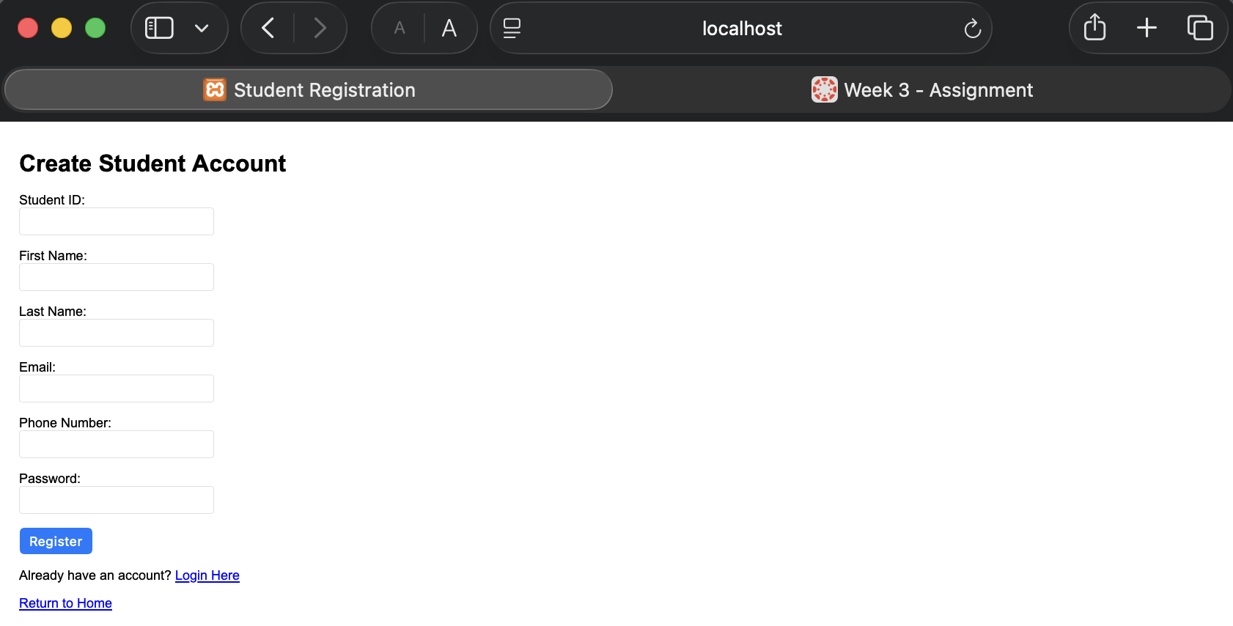Figure 4. Student registration page layout.
PHP was then added to the registration page to process the information submitted through the form. When the student selects Register, PHP collects the entered values and establishes a connection to the MySQL database. The password is hashed before it is stored. Password hashing is important because passwords should not be stored as readable plain text in a database (OWASP Foundation, n.d.).
The registration code uses a prepared SQL statement to insert the student information into the Users table. According to the PHP Group (n.d.), prepared statements allow values to be bound to parameters before a statement is executed and also help protect against SQL injection. In this project, the student information is bound to the prepared statement and then inserted into the database. The page displays a registration successful message when the process is completed correctly.
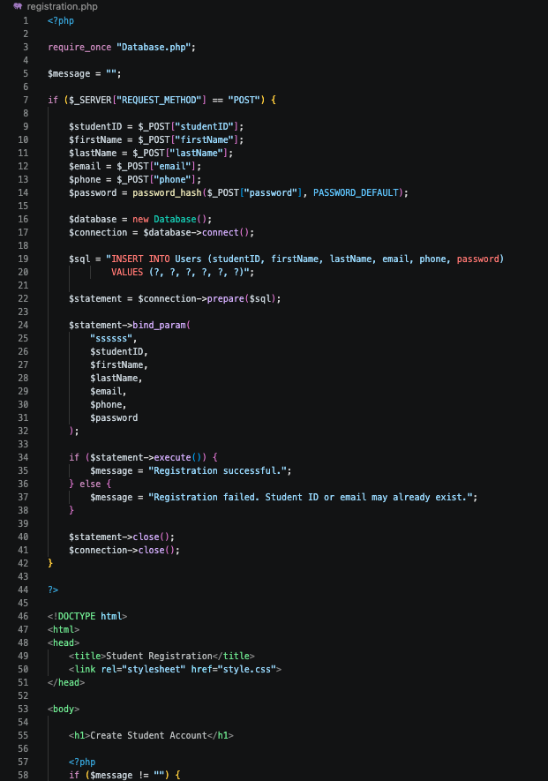
Figure 5. PHP source code used to process and save registration information.
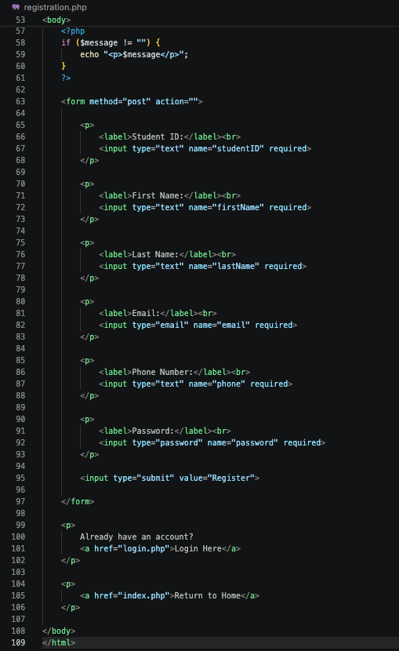
Figure 6. Registration form source code.
MySQL Database and Database Connection
A MySQL database named course_enrollment was created through phpMyAdmin. Inside the database, a Users table was created to store account information. The table contains seven fields: id, studentID, firstname, lastname, email, phone, and password. MySQL allows tables to be designed with different columns and data types based on the information that needs to be stored (Oracle, n.d.). VARCHAR was used for most of the student information because the values contain text or vary in length.
The id field uses an automatically increasing integer and serves as the primary key. Student ID and email were configured as unique values to prevent multiple accounts from using the same identifying information. The password field allows additional space because the system stores a password hash rather than the original password.
A custom Database class was created in Database.php to handle the connection between PHP and MySQL. The class contains the host, username, password, and database name required for the connection. The connect function uses mysqli to establish the connection. It also checks for a connection error before returning the active database connection. Keeping this process in its own class makes it easier for other PHP pages to use the same database connection without rewriting the connection information each time.
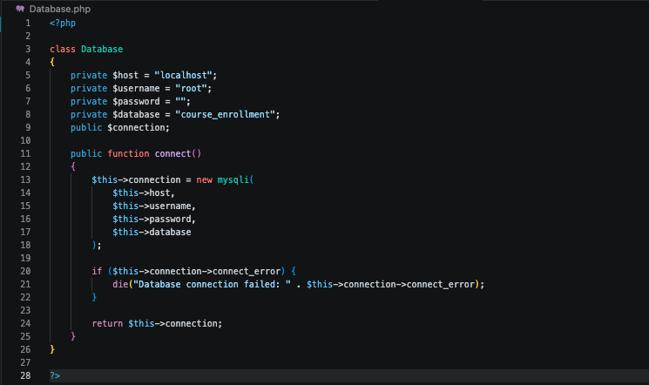Figure 8. Custom PHP database connection class.
The main database functions used during registration were prepare, bind_param, execute, and close. The prepare function prepares the SQL INSERT statement. The bind_param function connects the values entered by the user with the placeholders in the SQL statement. The execute function sends the completed statement to MySQL, while close is used when the statement and connection are no longer needed. These steps follow the basic prepare and execute process described in the PHP documentation (PHP Group, n.d.).
Saving Student Information
The final step was testing whether information entered through the registration page could actually be stored in MySQL. A test student account was created using the registration form. After the Register button was selected, the system displayed a successful registration message. The Users table was then opened through phpMyAdmin to verify the result.
The test record appeared in the table with the student's ID, first name, last name, email address, phone number, and hashed password. This confirmed that the registration page, PHP processing, database connection, and MySQL table were communicating correctly. The test also showed that the original password was not stored as readable text.
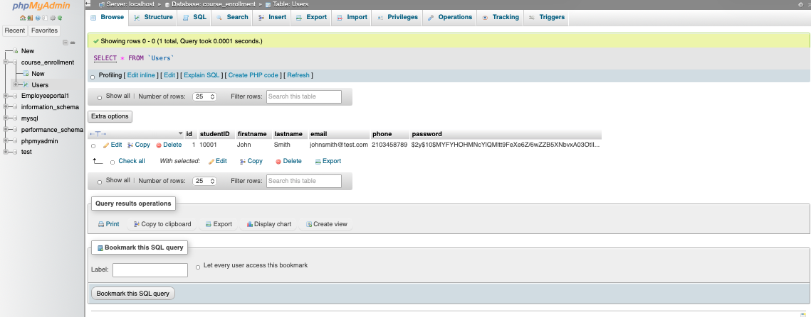Figure 9. Student registration information successfully stored in the Users table.
Conclusion
The implementation completed during this phase established the basic website and database functions for the Online Course Enrollment System. XAMPP provided the local environment for running PHP and MySQL, while the landing, login, and registration pages created the main user interfaces. The course_enrollment database and Users table provided a location for storing account information. PHP and a custom database connection class connected the registration form to MySQL, allowing a new student record to be successfully saved. The completed test demonstrated that the website can accept registration information and store it in the database, providing a working foundation that can be expanded as development continues.

References

OWASP Foundation. (n.d.). Password storage cheat sheet. OWASP Cheat Sheet Series. https://cheatsheetseries.owasp.org/cheatsheets/Password_Storage_Cheat_Shee
t.html
Oracle. (n.d.). Creating a table. MySQL 8.0 Reference Manual. https://dev.mysql.com/doc/refman/8.0/en/creating-tables.html
PHP Group. (n.d.). Prepared statements. PHP Manual. https://www.php.net/manual/en/mysqli.quickstart.prepared-statements.php
Tsui, F., Karam, O., & Bernal, B. (2018). Essentials of software engineering (4th ed.). Jones & Bartlett Learning.

